Clemson University Turfgrass Research & Education Field Day
August 16, 2022

Time:
8:45am til 12pm - Walker GC Maintenance Shop, (412 Cherry Road, Clemson, SC 29634)
12 til 1pm - lunch, (on your own)
~1:15pm - Behind-the-Scenes Tour of Clemson University’s Football & Baseball Complexes (Gate 10, DV)

Sponsored By:
Clemson University College of Agriculture, Forestry, and Life Sciences, Public Service Activities, Carolinas Golf Course Superintendents Association, SC Sports Turf Managers Association, and The Walker Golf Course

Special Thanks to SCSTMA for providing refreshments & printing.

Special, Special Thanks to the following for providing funding/supplies/labor to renovate the research plots during 2021:
- Tobey Wagner & Roberto Gurgel, Sod Solutions, Inc.
- Mills Grant, New Life Turf
- Andy Fogle, Carolina Fresh Farms
- Hank Kerfoot, Modern Turf, Inc.
- Bill and Tony Nimmer, Nimmer Turf
- Gary Youmans, Green Acres Turf Farm
- Mike Pitts, Environmental Landscaping Inc.
- Rob Hamrick, Golf Agronomics

NOTES:
SC, NC, & GA Pesticide Recertification, CCA/CPAg, and PTI Credits will be offered.
Costs: Free and Open to the General Public
Contact: Dr. Bert McCarty, 864-656-0120, bmccrty@clemson.edu

Hotel Reservations: The James F. Martin Inn at 888-654-9020.

Golf Tee Time Reservations: Walker GC Pro Shop at 864-656-0236

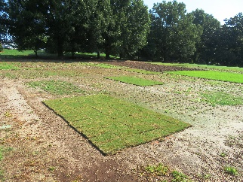 | 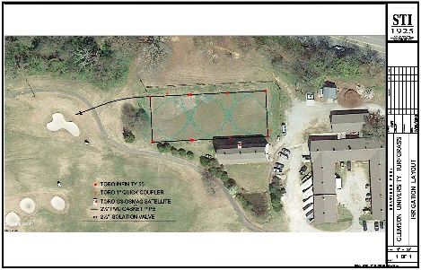 | 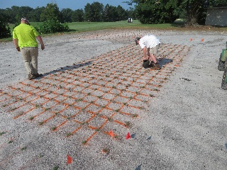 | 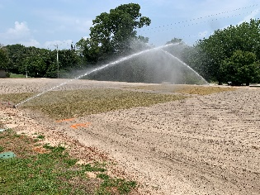

CLEMSON UNIVERSITY TURFGRASS RESEARCH
AND EDUCATION FIELD DAY

August 16, 2022 – 8:45 am
Walker Golf Course Maintenance Facility (412 Cherry Road, Clemson, SC 29634)
Clemson University, Clemson, SC

ITINERARY

8:45am Gathering at Walker GC Maintenance Facility (412 Cherry Road) (Stop 1).
Welcome and Explanation of the Field Day events and locations, Bert McCarty, Professor of PES
-Update on Federal Poa biology project; Jacob Taylor & Bert McCarty
-Update on Mini-Ring biology and control project; Luke Dant, Joe Roberts, Jim Kerns, & Bert McCarty
-Native Plant Selection for Out-of-Play Areas of South Carolina Golf Courses; Payton Davis and Dara Park
-Disease and fungicide management update; Joe Roberts
-Update on latest Control/Management Strategies for Bermudagrass Stunt Mites; Matt Brown & JC Chong,

9:45 First stops at research green adjacent Yellow Barn (Stop 2 on map below)
-POST Va. buttonweed, crabgrass, and spurge control trial; Bert McCarty & Tee Stoudemayer
-Selective control of bermudagrass off-types? Bert McCarty & Tee Stoudemayer
-New greens grade ultradwarf bermudagrasses for pest resistance and puttability; Tee Stoudemayer & Bert McCarty
-New greens grade ultradwarf zoysiagrasses for pest resistance and puttability; Bert McCarty & Don Garrett

10:45 Break

11:00 Educational Stops (Stop 3) with Refreshment Break Sponsored by SCSTMA
-Samurai for PRE control of Cock’s Comb Kyllina; Bob Cross & Bert McCarty,
-POST Cock’s Comb Kyllina control; Tee Stoudemayer & Bert McCarty,
-New bermudagrasses for fairways, sports fields, and home lawns for maximum pest resistance; Jacob Taylor, Bert McCarty & Tee Stoudameyer
-New zoysiagrasses for fairways and home lawns with inherent pest resistance; Adam Gore, Bert McCarty & Tee Stoudemayer
-St. Augustinegrass cultivar evaluation trial for turf performance; Bert McCarty,
-Evaluating a herbicide safener, Recognition, on zoysiagrass and bermudagrass; Bert McCarty, Luke Dant, Tee Stoudemayer,
-Copper tolerance of Tifeagle Bermudagrass; Adam Gore, Bert McCarty, & Virgil Quisenberry,

12-1pm Lunch (on your own)

~1:15pm Stinging from Sting Nematodes during 2021. Death Valley Football Stadium tour (Stop 4). Park in lot 5 behind the Oculus and meet inside Gate 10 (where the visiting team enters the field). Mike Echols, CU Sports Turf Field Manager & Bert McCarty

2-3pm Fraize (Fraze, Fraise, etc.) Mowing for Thatch Removal and Turf Recovery, Doug Kingsmore Baseball Field. Mike Echols and Jonathan Holland, Precision Turf
or
-Continued Self-guided Tours of the Turfgrass Research Facilities,

or
-Golf at Walker GC. Call the pro shop at 864-656-0236 for tee times

